AWS SQS
Introduction
It’s a messaging queuing service that provides queues for high-throughput and system to system messaging. So, it’s basically a one-to-one service. It is used to decouple heavy process work from the system to optimize the system response time. AWS SQS retain messages until a microservice or any serverless applications process them or a system consumes the message and delete them from the queue.

It enables async communication between components of a distributed system means systems can work without being directly connected that being tightly coupled. It acts as a buffer between different systems whether they are microservices or distributed systems or serverless applications, ensuring data transfer is reliably transferred between system even if one part or a system is slow or goes offline.
Problems Before SQS
Software systems were becoming larger, distributed and more complex - but communication between them were unreliable and are tightly coupled which result in difficulty in scaling systems.
- Tightly Coupled System - the system that directly communicate with each other directly and if one service of the system fails whole system goes down aur the entire chain could break. Due to this if changes take place in one system, then we need to make changes in all others.
- Unreliable Message Delivery - when system crashed or network failed, messages were lost completely creating problems for other system to function to solve this issue developers had to build a retry mechanism or some kind of a error handling system to solve the issue.
- Scalability Challenges - As internet grew, users traffic grew due to which direct communication between services couldn’t scale smoothly. Sudden spikes could overwhelm the system.
- Infrastructure Complexity - Building a message queue system from scratch was very difficult as it had to be fault tolerant, persistent and had to have retry logics and high availability. This lead developers spent too much time managing infra rather than writing business logic.
SQS Changed the World
It redefined how software systems communicate. It made systems be more scalable and reliable. In system design it introduced a concept of decoupling and asynchronous communication. Also brought a cloud evolution for serverless and event-driven architectures.
- Pioneered Cloud Messaging - Before SQS, message queues were usually built-in house using complex middleware like IBM MQ, RabbitMQ or MSMQ - expensive, hard to scale and difficult to maintain.
After SQS, SQS was the first web-based managed queue service that anyone could access over the internet using simple APIs. It made reliable message queuing accessible to everyone. It reduced the cost and effort of building distributed systems but now it became a core building block for the cloud era.
- Enabled Loosely Coupled, Scalable Systems - It introduced the concept of “decoupling” allowing different parts of the application to work independently, without waiting for each other.
- This led to microservices architecture, where each service focuses on one job.
- Prevented cascading failures - Earlier if one service goes down the whole systems breaks but now if one system slows down or breaks there is no longer breaks everything.
- Allowed horizontal scaling which makes more systems to add together when traffic spikes.
- Laid foundation for serverless Computing - It became cornerstone for event-driven and serverless systems. And when combined with AWS Lambda, allows developers to trigger functions automatically when messages arrive and run code without provisioning or managing servers.
- Simplified backend development dramatically.
- Paved the way for pay-per-use, zero-maintenance architectures.
- Improved global application performance - It operates across multiple AWS Availability Zones, ensuring that message isn’t lost even if data centres fail. Enable global-scale architectures that remain reliable 24/7.
- Set a standard for cloud design - It changed the way how developers think, a switch from monolithic to event-driven architectures. From direct connections between systems to message-based decoupling. Helped companies from maintaining heavy infra to managed infra and pay-as-you-go services. Also defined the best practices for reliable, scalable cloud systems.

Where SQS is used in industry
- E-commerce - Order processing, inventory updates, payment confirmation.
- Banking/Finance - Transaction queues, fraud detection systems.
- Healthcare - Secure message flow between systems for patient data or IOT devices.
- Gaming - Real-time event processing and game state updates
- IOT - device telemetry buffering and event-driven control.
Benefits of using SQS
- Scalable & Elastic - Automatically handles any amount of traffic.
- Reliable & Durable - Messages are redundantly stored across multiple availability zones.
- Decoupling of systems - Enables modular, maintainable architecture.
- Cost-Effective - Pay only for what you use.
- Secure - Supports encryption and AWS IAM integration.
- Integration with other AWS Services - works well with Lambda, SNS, EC2, S3 and step Functions.
- Multiple Queue Types:
- Standard Queues - Unlimited throughput, at-least-once delivery.
- FIFO Queues - First-In-First-Out with exactly-once processing.
Disadvantages/Limitations
- Latency - Slightly delay in message delivery (usually millisecond)
- Limited Message Size - Max message size is 256 KB.
- Vendor Lock-In - Tightly coupled with AWS ecosystem.
- Visibility Timeout Complexity - Requires careful config to prevent message reprocessing.
- No order in the standard queue if it’s not a FIFO Queue.
- Not Ideal for Real-Time Low Latency systems - Best for Async communications.

AWS SQS Console
Get your first AWS account or companies AWS account and login to your AWS account in the service bar at the top left corner search for SQS in the search bar.
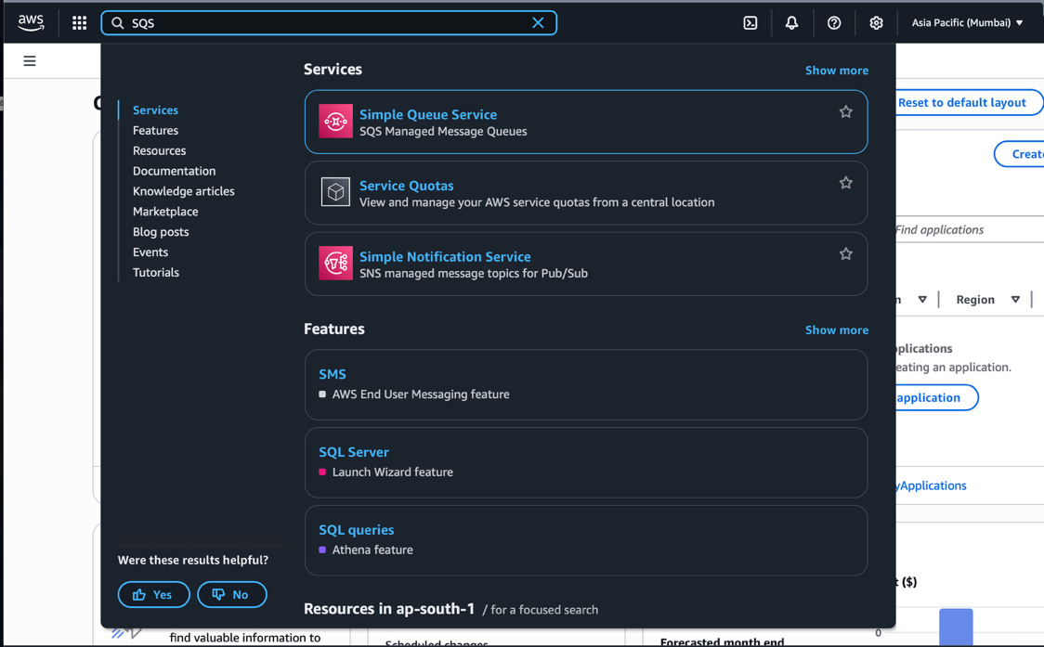
How to create first queue
Click on the “Create queue” button on the window.
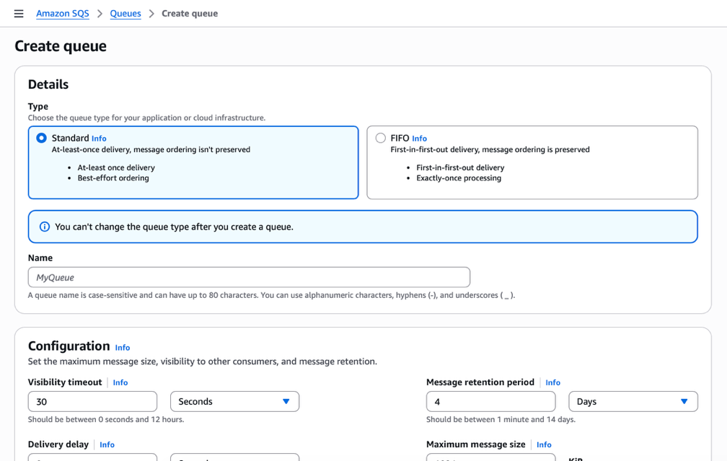

Choose between the two types of queues: -
- Standard queue - It is a default type in Amazon SQS console and is built for a high throughput, scalability and best-effort ordering which can be ideal for workloads that process a large volume of messages quickly.
- Process almost unlimited number of transactions per second and delivers within milliseconds.
- Each message is delivered at least once, but sometimes more than once.
- The order of message delivery is not guaranteed but message may arrive out of sequence.
- Message are stored redundantly across multiple AWS Availability Zones for durability.
- FIFO queue - It is designed for use cases where order and exact-once processing are critical. It ensures that messages are processed in the exact order they are sent and each message is delivered only once.
- It ensures that the message is processed only once.
- It ensures the exact order of the message that in which they were sent.
- It has a limit of 300 message transactions per sec or 3,000 if batching.
- It has a built-in reduplication system to prevent duplicate message deliveries.
- Multiple ordered message groups within the same queue.
So, choose depending upon the use case but as a suggestion always use standard queue rather than FIFO queue and use FIFO only when order of messages is very important.
Then simply name your queue that is whatever you want your queue to be called.
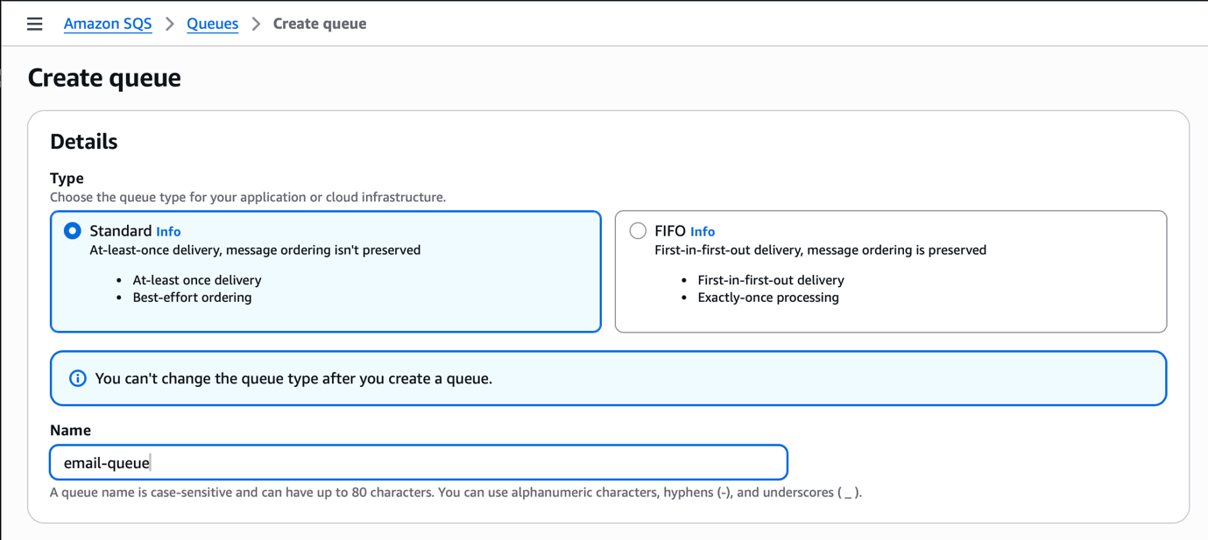

Configure your SQS depending upon the use case
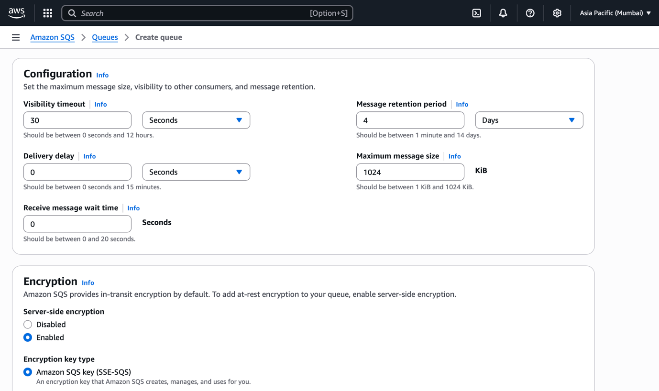
Visibility timeout - It is a period for a message to become invisible to other consumers (it won’t be seen or consumed by other consumers) after one consumer retrieves it from the queue.
- When a consumer (like an EC2 instance or lambda function) reads a message, SQS hides the message for the visibility timeout duration. The AWS Lambda automatically deletes the message after successful processing of the message, but it only happens when lambda is SQS triggered. Any system beyond this must delete the message.
- If the consumer processes and deletes the message within the time-period of visibility timeout it’s great.
- But if the consumer fails (doesn’t delete it in time), the message becomes visible again, so another consumer can process them.
- Default: 30 Sec and Ranges: 0 seconds to 12 hours
It is suggested that visibility timeout to be set slightly longer than the average message processing time.

Message retention period - It is how long the AWS SQS keeps a message in the queue if it’s not deleted by a consumer. If the message isn’t processed before the retention time expires, SQS automatically deletes it.
- Default: 4 days and Ranges: 60 seconds -> 14 days
It is suggested that retention period should be set enough to handle backlogs or outages.
Delivery delay - It is how long SQS waits before making a new message available to consumers after it’s sent to the queue which is it acts like a time delay or a message holder for the period that is set in the delivery delay.
- It acts like a “hold timer” which is useful if we want to postpone processing messages for a while.
- Default: 0 seconds and Range: 0 -> 15 minutes
It is suggested that delaying retry attempts after a failed payment or waiting before sending follow-up notifications.
For Example - we set delivery delay at 10 minutes, so when we send a message at 9 to a queue it won’t be visible or available to consumers until 9:10.
Not to confuse - delivery delay is used when we need to make a message available after a period passed for consumer to consume and visibility timeout is when a message is consumed that message become invisible to other consumers once the message is consumed and will only be visible after the visibility timeout if the message is not deleted.
Maximum message size - It defines the largest allowed size (in bytes) of a single SQS message. A message includes the body and any metadata (attributes).
- Default: 256 KB and Ranges: 1KB to 256KB
It is suggested that for larger payloads we need to store them in AWS S3 and send the S3 object URL via SQS instead.
For Example - if we try to send a 300KB message, AWS SQS will reject it.
Receive message wait time - It controls how long the ReceiveMessage call waits for a message to arrive before returning an empty response. There are two types of polling: -
- Short Polling (default) - Returns immediately, even if no message is available.
- Long Polling - Waits up to a specified time (max 20 seconds) for messages to appear, reducing empty responses and costs.
- Default: 0 seconds (short polling) and Range: 0 to 20 seconds
It is suggested to use Long Polling so that we have lower cost and make fewer API calls plus we get faster message delivery
For example - When we set the Receive Message wait time to 10 seconds, when consumer polls the queue and no message are available SQS waits up to 10 seconds before responding and if message arrives during the 10 second period it delivers the message immediately.
When a lambda is made SQS triggered it makes empty calls to SQS for messages, it costs a request so when lambda is made of this type it makes a request call to SQS depending upon the Receive Message config value. And if the receive message is set to 0, it will request SQS every second and these requests add up to the SQS bill costing for every request that was made.
Encryption
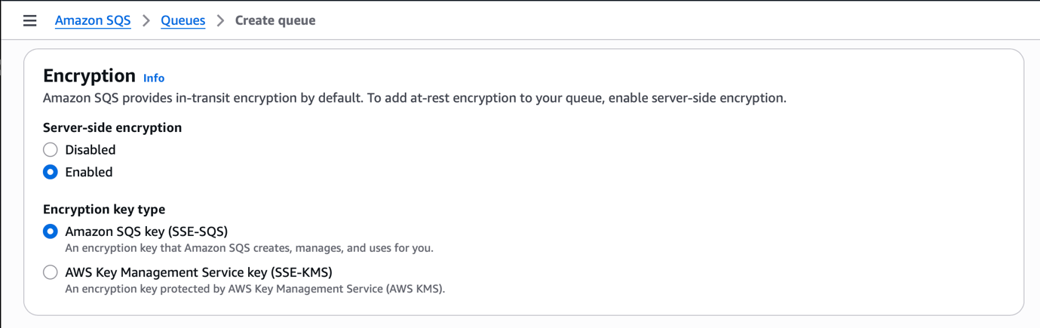
So, there is an option to Encrypt your body in the AWS SQS message, if you don’t want to encrypt then disable the Server-side encryption.
If select enabled in the SSE then we have two options whether to choose Amazon SQS Key (SSE-SQS), it is managed by Amazon SQS, or we can choose AWS KMS key (SSE-KMS) it encrypts the message body with the AWS KMS key.
When selected we have
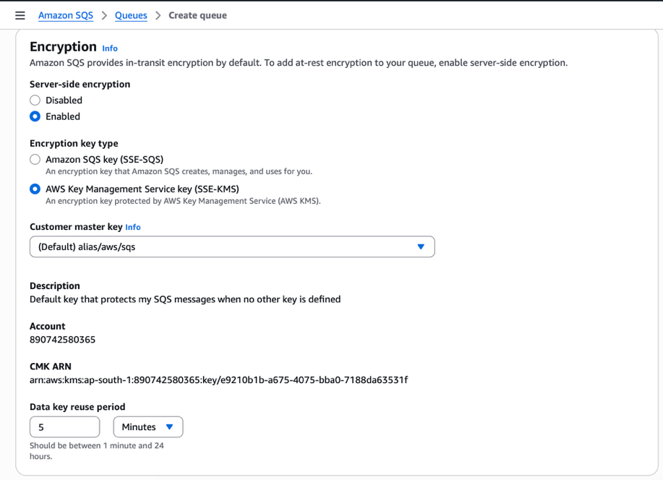
A default key that protects SQS message body when no AWS KMS key is defined but if we have, we can select that as well.
We see our CMK: ARN that is being used when we select the key. We also have option to control the calling KMS for every single message. Through this option we can reduce the latency and the cost of calling KMS and this option is called Data Key Reuse Period.
Data Key Reuse Period is the duration for which SQS reuses the same data key to encrypt or decrypt multiple messages in a queue before requesting a new key from AWS KMS. The SQS checks if there’s an existing data key that’s still within the reuse period and if its yes, the SQS reuses that same key to encrypt it else SQS requests a new data key from AWS KMS automatically.
By Default, Value it’s 300 second and ranges from 60 seconds to 86,400 seconds.
Access Policy
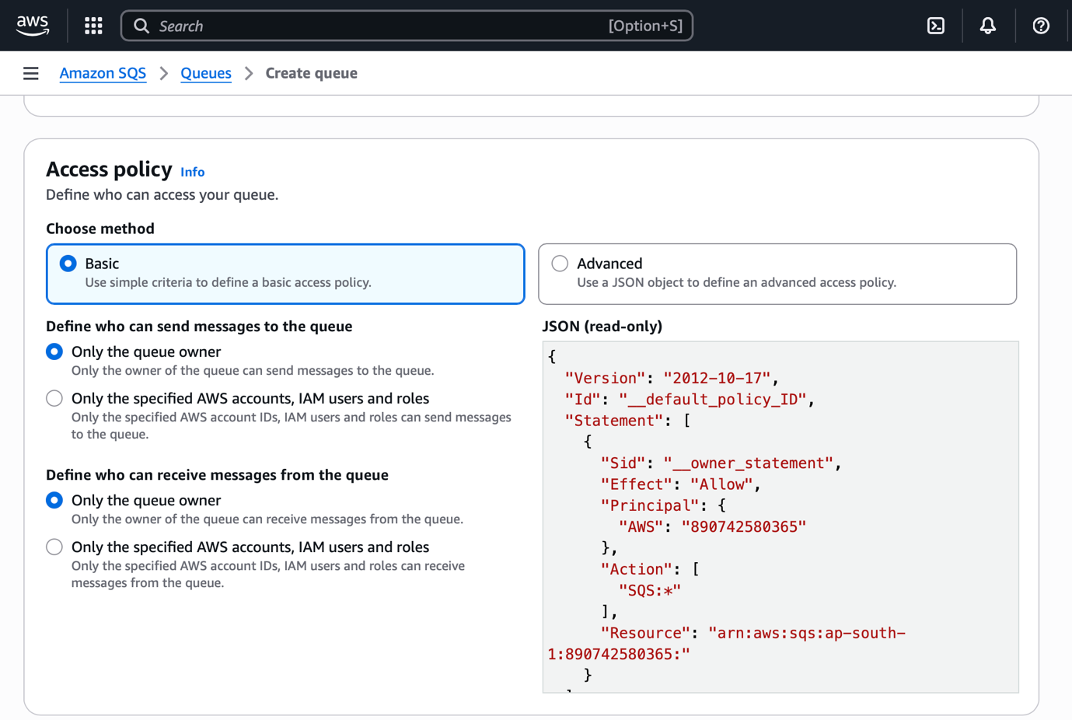
It’s simple we have two option to define who can send or receive messages from and to the queue when selected method as Basic, but we selected Advanced things gets little more interesting.
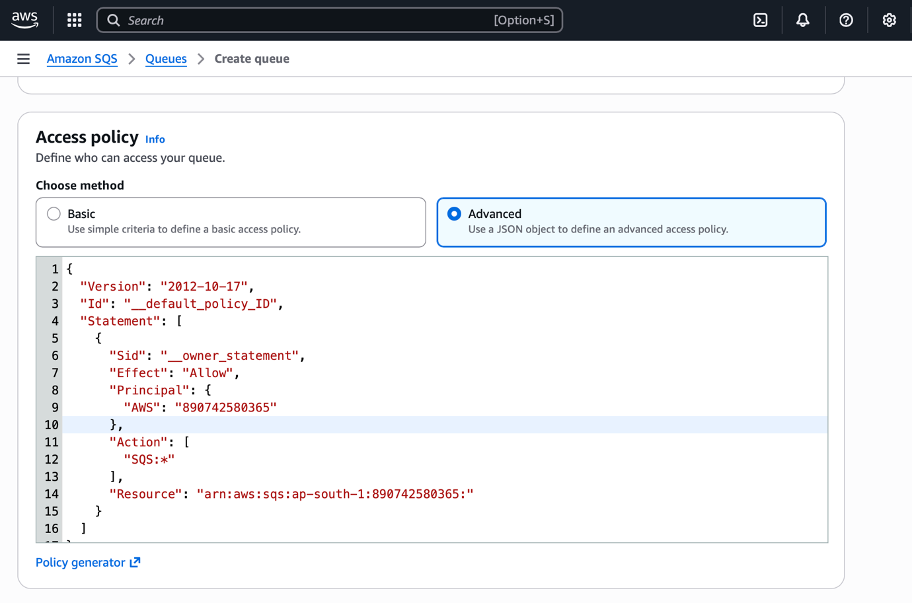
Version - This is the only valid version for SQS policies and cannot create a custom version string and can’t be omitted but it’s best practice to include it.
Id - An optional identifier for policy itself, it’s a simple string used to label the entire policy document. It doesn’t affect permissions and can’t have multiple Id keys - only one per policy.
Statement - This is the core section of policy that is it’s a list of one or more permission rules that define who can do what on the queue. Each object in array has sub-keys like Sid, Effect, Principal, Action, Resource and optionally Condition.
Sid - a unique identifier for this individual statement within the policy. Helps distinguish between multiple permission blocks.
Effect - Defines whether the action is allowed or explicitly denied so even other policies allow the action.
Principal - Specifies for whom the permission applies to (which AWS account, user, role, or service). You can add multiple forms in the principal key value separated by comma.

Form | Example | Meaning
AWS Account ID | “AWS”: “34838942648” | Allow all the users in that AWS account
IAM Role/User ARN | “AWS”: “arn:aws:iam:424234244:role/MyRole” | Allows a specific role or user
AWS Service | “Service”: ”sns.amazonaws.com” | Grants access to an AWS service like SNS or Lambda
Wildcard | “AWS”: “*” | Grants access to everyone which is not recommended

Action - What operations the specified principals can perform on the queue.
sqs:SendMessage | Allows sending messages to the queue
sqs:ReceiveMessage | Allows receiving messages from the queue
sqs:DeleteMessage | Allows deleting a message from the queue
sqs:ChangeMessageVisibility | Allows changing the visibility timeout of a message in flight
sqs:GetQueueAttributes | Allow reading queue attributes
sqs:SetQueueAttributes | Allow updating queue configuration
sqs:GetQueueUrl | Allow retrieving the URL of the queue
sqs:TagQueue | Allows adding tags to a queue
sqs:UntagQueue | Allows removing tags from a queue
sqs:ListQueueTags | Allows listing existing tags on a queue
sqs:ListDeadLetterSourceQueues | Allows listing source queues that send messages to this queue as a DLQ
sqs:PurgeQueue | Allows deleting all the messages from the queue
sqs:SendMessageBatch | Allows sending multiple messages at one
sqs:DeleteMessageBatch | Allows deleting multiple messages at one
sqs:ReceiveMessageWaitTimeSeconds | Controls long-polling config for message retrieval
sqs:* | Allows full access.

Resource - Specifies which SQS queue(s) the permissions apply too. It must be an ARN for an SQS queue.
Valid format - arn:aws:sqs:<region>:<account-id>:<queue-name>
When you define an access policy for a specific queue, that policy applies only to that queue, even if you list multiple queue ARNs or services in the “Resource” field. Each SQS enforces only its own policy.
Condition (Optional but Powerful) - used to limit when or how the permission applies based on context.
Operator | Condition Keys used | Type of comparison | Common Use in SQS
ArnEquals | aws:SourceArn | Exact match of ARNs | Restrict to a specific service’s ARN
ArnLike | aws:SourceArn | ARN match using wildcards (*) | Allow all the services matching a pattern
StringEquals | aws:SourceAccount, aws:PrincipalArn, aws:SourceVpce | Exact match of string value | Restrict to a specific AWS account
StringLike | aws:SourceArn, aws:PrincipalArn, aws:SourceVpce | String match using wildcards (*) | Allow roles or resources with partial name matches
Bool | Aws:SecureTransport | True/False comparison | Enforce HTTPS access
IpAddress | aws:SourceIp | Match specific IP or CIDR range | Restrict access to specific IP ranges (rarely used in SQS)
ArnNotEquals | aws:SourceArn | Deny if ARN does not match | Block unwanted services
StringNotEquals | aws:SourceAccount, aws:PrincipalArn | Deny if string does not match | Used in explicit deny rules
Null | aws:SourceAccount, aws:SourceArn | Check if a key exists or not | Ensure keys are present or not
StringEqualsIfExists / ArnEqualsIfExists | aws:SourceAccount, aws:SourceArn | Apply match only if the condition key exists | Optional matching for flexible policies
Operators are case-sensitive, and you can combine multiple operators in one condition block. ArnEquals and StringEquals are most used in SQS policies, especially for SNS-to-SQS or Lambda-to-SQS access control.

Redrive allow policy
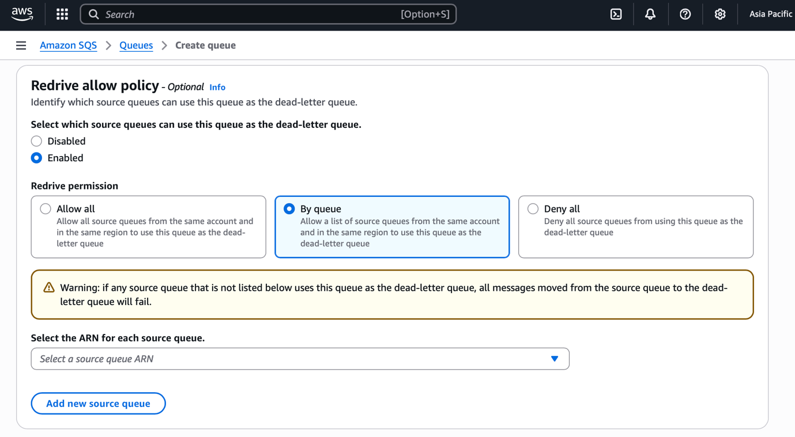
This policy is enabled when we need to make a queue to work as a DLQ (Dead Letter Queue) that is which source queues are allowed to use this queue or the queue to work as DLQ and send message to this queue. It’s simply a queue that receives the failed messages of other queues.
In this we have three permissions
- Allow all: when selected this all the queues from the same account and same region can use this queue as the DLQ
- By queue: When selected this option only selected queues from the same account and region can use this queue as the DLQ.
- Deny all: When selected this option we deny all source queues of the account to use the queue as DLQ

Dead Letter Queue
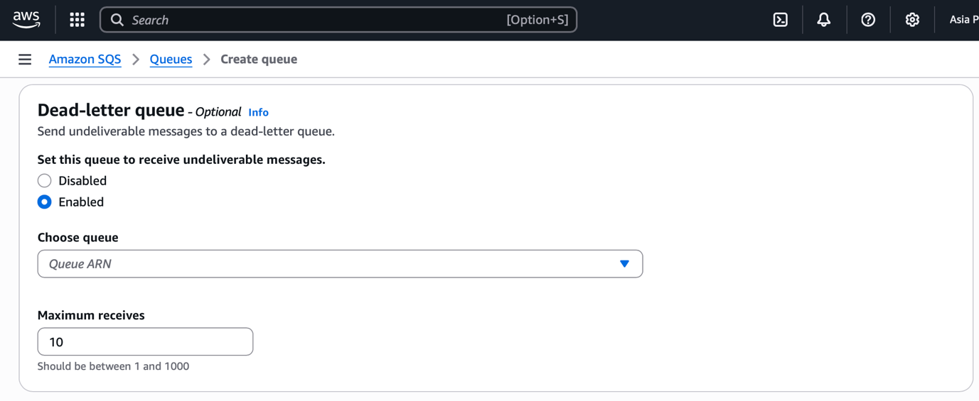
With this option enabled we can send messages to a DLQ of the same account and region. We need to select to which DLQ we want to send the message
Then we have Maximum Receives which is configured to determine how many times a message can be received from the resource queue before it moves automatically to a DLQ. It’s a retry limit for a failed message processing in the source queue.
For Example - if we set the maximum receive count as 5 and if message fails to be processed successfully 5 times, then on 6th attempt SQS automatically moves the message to the desired DLQ.

AWS IAM
All IAM Permission that we can define for the SQS users, roles or define policies.

sqs:SendMessage | Allows sending messages to the queue
sqs:ReceiveMessage | Allows receiving messages from the queue
sqs:DeleteMessage | Allows deleting a message from the queue
sqs:ChangeMessageVisibility | Allows changing the visibility timeout of a message in flight
sqs:GetQueueAttributes | Allow reading queue attributes
sqs:SetQueueAttributes | Allow updating queue configuration
sqs:GetQueueUrl | Allow retrieving the URL of the queue
sqs:CreateQueue | Allows creating a new queue
sqs:DeleteQueue | Allows deleting an existing queue
sqs:ListQueues | Allows listing all queues owned by the account
sqs:TagQueue | Allows adding tags to a queue
sqs:UntagQueue | Allows removing tags from a queue
sqs:ListQueueTags | Allows listing existing tags on a queue
sqs:AddPermission | Allows adding a permission statement to the queue policy
sqs:RemovePermission | Allows removing a permission statement from the queue policy
sqs:ListDeadLetterSourceQueues | Allows listing source queues that send messages to this queue as a DLQ
sqs:PurgeQueue | Allows deleting all the messages from the queue
sqs:SendMessageBatch | Allows sending multiple messages at one
sqs:DeleteMessageBatch | Allows deleting multiple messages at one
sqs:ReceiveMessageWaitTimeSeconds | Controls long-polling config for message retrieval
sqs:* | Allows full access.

This is the window that will be shown when we create a first queue
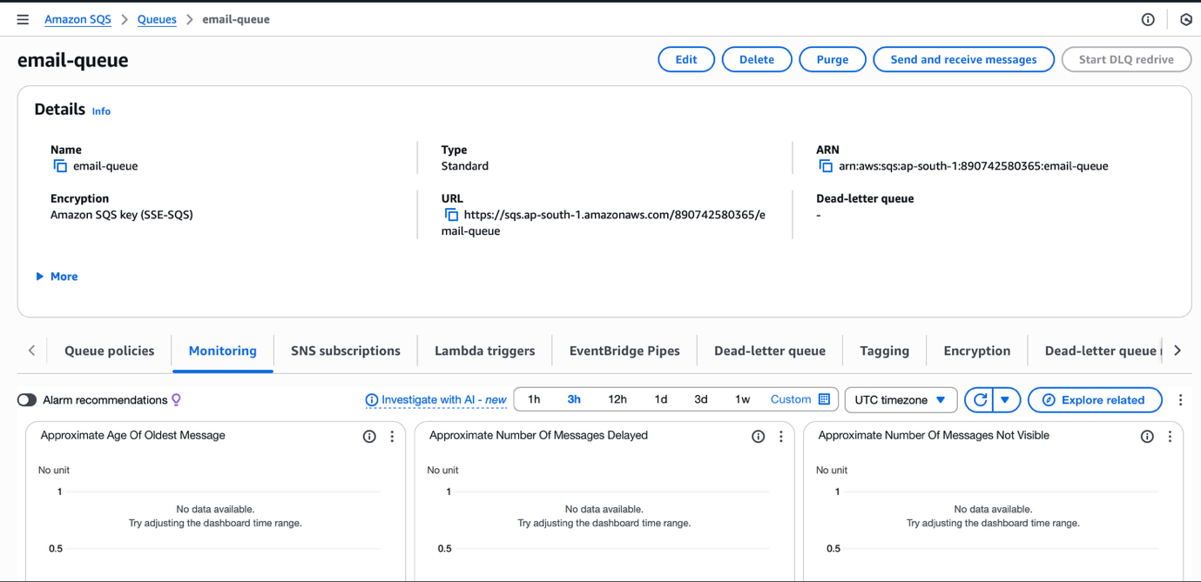
On top we ca see our SQS queue name with some action buttons: -
- Edit - through this we can edit our queue configurations
- Delete - we can delete our queue
- Purge - this is a sensitive option through this u will delete all the messages in the queue.
- Send and Receive Messages - through this option we switch to different window where we can see and send message from the queue.
- Start DLQ redrive - this helps u to see the DLQ message in the queue.

Send Message
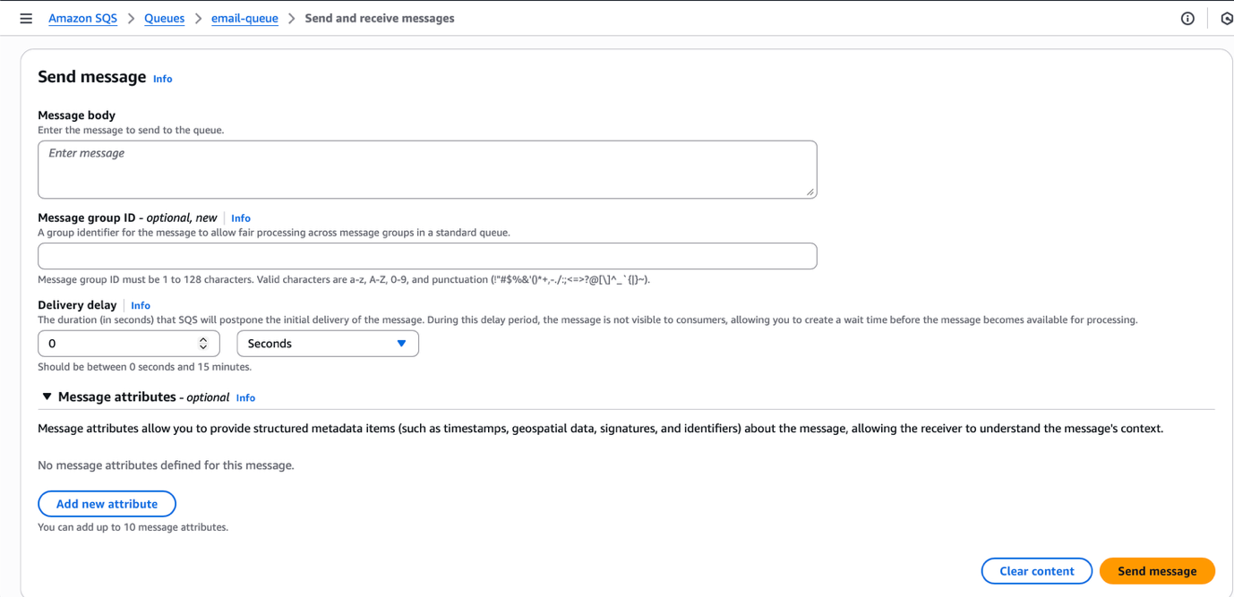
Message body - We can send message to this queue to test it.
Message group ID - It is an identifier that logically groups related messages together within a FIFO queue. All messages which the same message group Id are processed in exact order, one at a time. It is not used in Standard Queues as it doesn’t preserve order and they deliver messages at least once and in any order.
Messages with the same MessageGroupId - Delivers and process sequentially, in the exact order they were sent.
Message with the different MessageGroupIds - Can be processed in parallel, improving throughput.
Message Attributes - You can add a new attribute defining attribute name, data type of the attribute name and adding a custom type as well then, we define a value for that attribute.
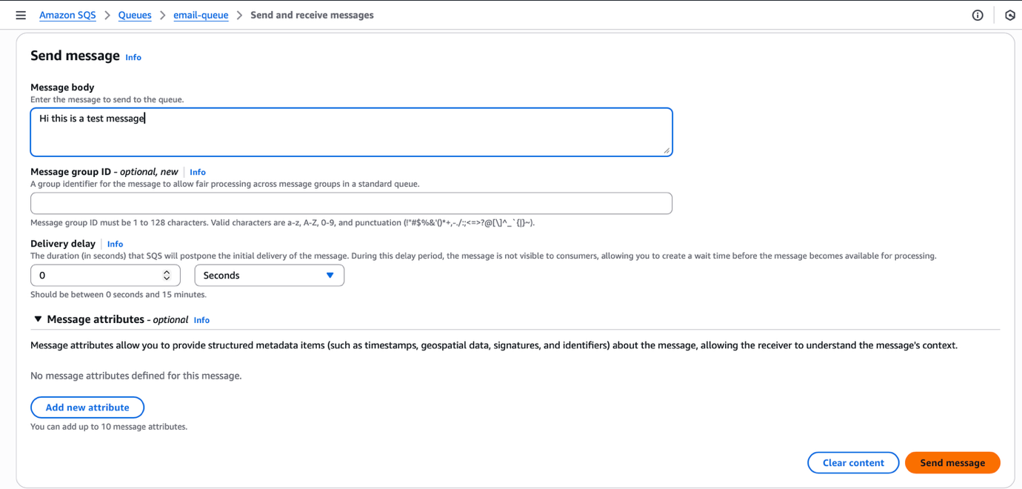
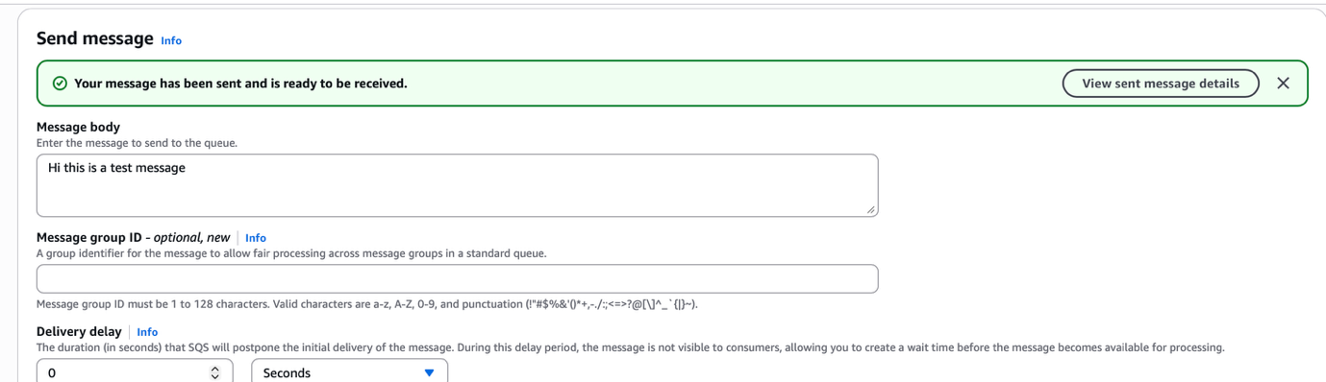

Receive Message


